Initial A, B test; Sending goals to the navigation stack

Ref: https://www.youtube.com/watch?v=Zjb_2krr1Xg&t=4s

tractor@tractor-HP-ProBook-645-G1:~$ rostopic info /move_base_simple/goal
Type: geometry_msgs/PoseStamped
Publishers:
* /rviz_1671969034667644838 (http://tractor-HP-ProBook-645-G1:44473/)
Subscribers:
* /move_base (http://tractor-HP-ProBook-645-G1:36243/)

Example:
$ rostopic pub /initialpose geometry_msgs/PoseWithCovarianceStamped

# (x, y, z, rotation about X axis, rotation about Y axis, rotation about Z axis)

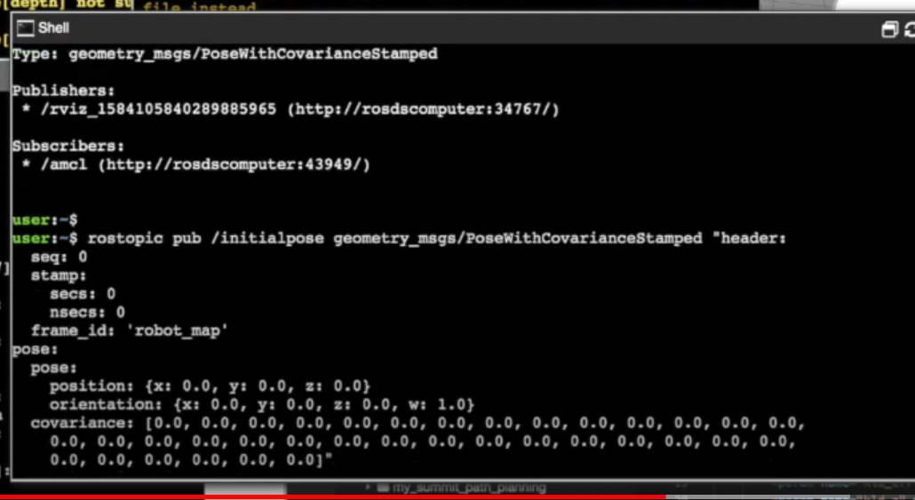

Starting position
frame_id: "map"
pose:
position:
x: 17.72983169555664
y: -1.9225318431854248
z: 0.0
orientation:
x: 0.0
y: 0.0
z: 0.6102695466483432
w: 0.7921938401891457

Target position
header:
seq: 2
stamp:
secs: 2494
nsecs: 242000000
frame_id: "map"
pose:
position:
x: 20.198528289794922
y: 9.454941749572754
z: 0.0
orientation:
x: 0.0
y: 0.0
z: 0.6394539905255735
w: 0.7688293659850147
---

Example python code
https://hotblackrobotics.github.io/en/blog/2018/01/29/action-client-py/

ROS2 demo of nav waypoints
https://www.youtube.com/watch?v=F2h7ZuJW8y0

